# **Cosmic Timeline Whitepaper**

### ***Version 1.0 – 2025***

## **Table of Contents**

1. Executive Summary
2. Introduction
3. Vision & Mission
4. Core Components of the Ecosystem
   * 4.1 Community-Driven Development
   * 4.2 Dynamic Tokenomics
   * 4.3 NFT Integration
5. Cosmic Farmer Game
   * 5.1 Key Features
   * 5.2 Game Mechanics
6. Cosmic Realm Game
   * 6.1 Core Features
   * 6.2 Economic Model & Monetization
   * 6.3 Community Engagement & Development
7. Cosmo Kitty NFTs
   * 7.1 Utility &
   * 7.2 Governance Particip Benefits ation
   * Cosmo Kitty NFT Sneak Peeks
8. CosmoSprout Token
   * 8.1 Token Utility
   * 8.2 Tokenomics
9. Roadmap & Future Developments
   * 9.1 Immediate Goals
   * 9.2 Mid-Term Goals
   * 9.3 Long-Term Vision
10. Conclusion

## **1. Executive Summary**

**Cosmic Timeline** is an innovative cryptocurrency and gaming ecosystem that merges decentralized governance, interactive gaming, and NFT integration. This project introduces **Cosmic Farmer** and **Cosmic Realm**, two interconnected games that create a self-sustaining digital world.

With **CosmoSprout Token (COSMOSPROUT)** at the heart of the economy and **Cosmo Kitty NFTs** providing governance power and in-game advantages, Cosmic Timeline is shaping the future of decentralized gaming.

The ecosystem is fully **community-driven**, ensuring that every update, economic model, and major decision is guided by its players and investors.

## **2. Introduction**

Cosmic Timeline was founded on the principles of **decentralization, collaboration, and continuous evolution**. By integrating cryptocurrency, NFTs, and virtual interactions, we aim to create a **self-sustaining, player-governed digital universe**.

Through engaging gameplay and economic incentives, we provide an opportunity for users to **earn, trade, and invest** in a dynamic, ever-growing ecosystem.

## **3. Vision & Mission**

### **Vision Statement**

*"To create a sustainable and community-driven ecosystem where gaming, cryptocurrency, and digital assets merge into a decentralized economy that rewards innovation, creativity, and participation."*

### **Mission**

* Establish a **player-driven metaverse** where individuals can engage in farming, business, and social activities.
* Provide **real economic opportunities** by linking in-game assets to blockchain-based value.
* Use **NFTs and DeFi mechanics** to empower users with governance control.
* Ensure **continuous expansion** through community feedback and adaptable tokenomics.

## **4. Core Components of the Ecosystem**

### **4.1 Community-Driven Development**

* Governance will be **fully decentralized**, with players voting on game updates, tokenomics adjustments, and new feature integrations.
* **Transparency and Collaboration**: Developers will interact with the community regularly, ensuring all decisions align with player interests.

### **4.2 Dynamic Tokenomics**

* **Adaptable Supply**: The supply of **CosmoSprout Token (COSMOSPROUT)** will adjust based on market demand and community governance.
* **Sustainable Growth**: Tokenomics will support long-term stability by encouraging **earning, staking, and reinvestment**.

### **4.3 NFT Integration**

* **Cosmo Kitty NFTs** will grant governance power, allowing holders to shape the ecosystem.
* These NFTs will provide **in-game benefits**, such as power boosts, special abilities, and unique items.

## **5. Cosmic Farmer Game**

### **5.1 Key Features**

* **Cosmic Farming**: Players cultivate crops on **different planets**, each with unique resources.
* **Upgrades & Progression**: Tools such as fertilizers, hoes, and magical potions enhance gameplay.
* **In-Game Economy**: Earn virtual coins through farming and selling plant-based products.

### **5.2 Game Mechanics**

* Players **start with basic resources** and progress by reinvesting earnings into new tools and upgrades.
* Coins earned from farming will eventually be **linked to cryptocurrency**, enabling real-world value.

## **6. Cosmic Realm Game**

### **6.1 Core Features**

* **Entrepreneurship & Business**: Players establish shops, restaurants, and entertainment centers.
* **Social Interaction**: Events, competitions, and networking opportunities foster community engagement.
* **Creative Competitions**: Users can showcase art, music, and writing to earn rewards.

### **6.2 Economic Model & Monetization**

* Business revenue will generate in-game currency, which can be **reinvested or traded**.
* Monetization will include **NFTs, premium memberships, and sponsorships**.

### **6.3 Community Engagement & Development**

* The game will evolve **based on player feedback**, ensuring fresh and exciting content.
* A **voting system** will allow the community to decide on major game expansions.

## **7. Cosmo Kitty NFTs**

### **7.1 Utility & Benefits**

* **Governance Participation**: NFT holders influence the game’s evolution.
* **In-Game Power Boosts**: Exclusive advantages in **Cosmic Farmer** and future games.
* **Airdrops & Rewards**: Regular incentives for active NFT holders.

### **7.2 Governance Participation**

* Cosmo Kitty NFTs act as **voting tokens**, determining ecosystem updates and major decisions.

### **7.3 Cosmo kitty NFT Sneak Peeks**

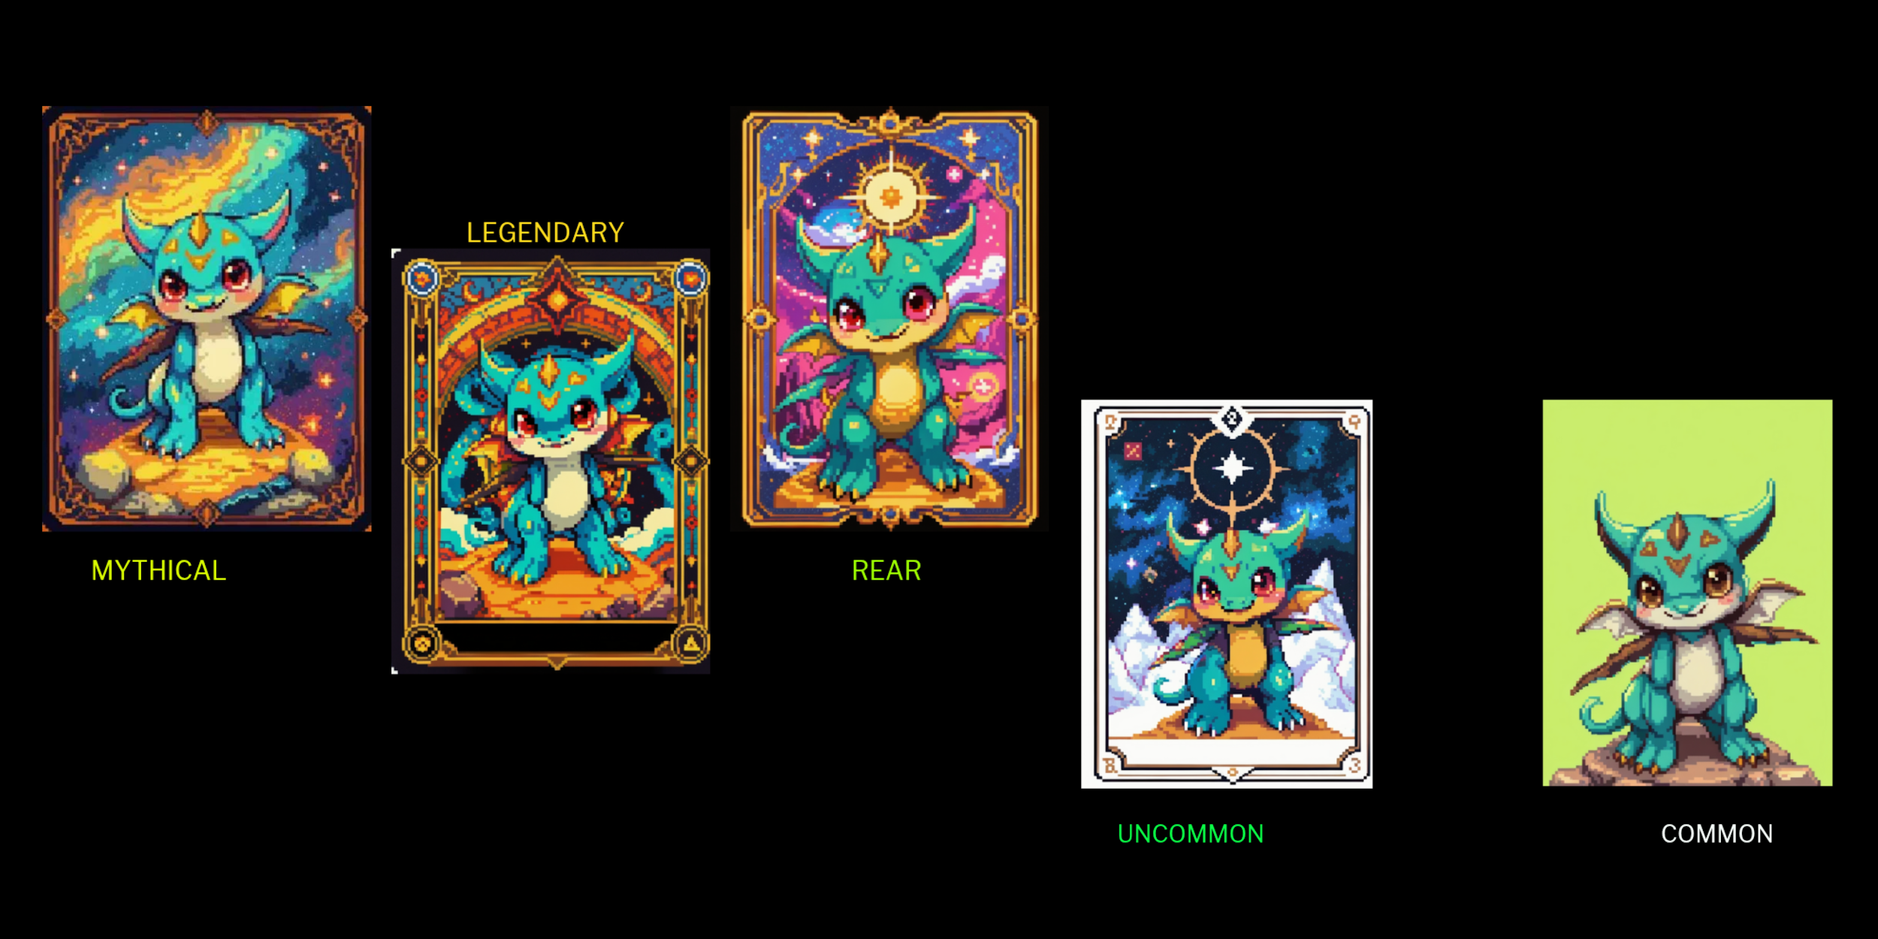

## **8. CosmoSprout Token**

### **8.1 Token Utility**

* In-game transactions and upgrades.
* Governance voting and decision-making.
* Staking for **passive income rewards**.

### **8.2 Tokenomics**

* **Token Name**: CosmoSprout
* **Symbol**: COSMOSPROUT
* **Total Supply**: 1,150,000,000

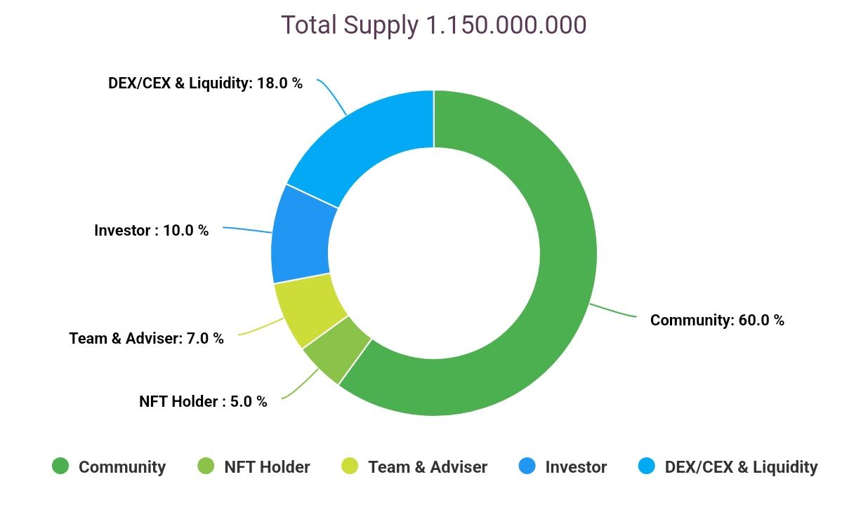

## **9. Roadmap & Future Developments**

### **9.1 Immediate Goals**

* **Build a strong community** through events and engagement.
* **Launch the Cosmo Kitty NFT collection**.
* **Deploy smart contracts** for security and transparency.

### **9.2 Mid-Term Goals**

* **Whitelist & Guaranteed Mint Spots** for early supporters.
* **Launch a play-to-earn mini-game** for community engagement.
* **Secure listings on DEX and CEX** to provide liquidity.

### **9.3 Long-Term Vision**

* **Full Launch of Cosmic Realm** with advanced social and business mechanics.
* **Cryptocurrency integration** across all ecosystem projects.
* **Expansion into the metaverse** with new virtual worlds and economic opportunities.

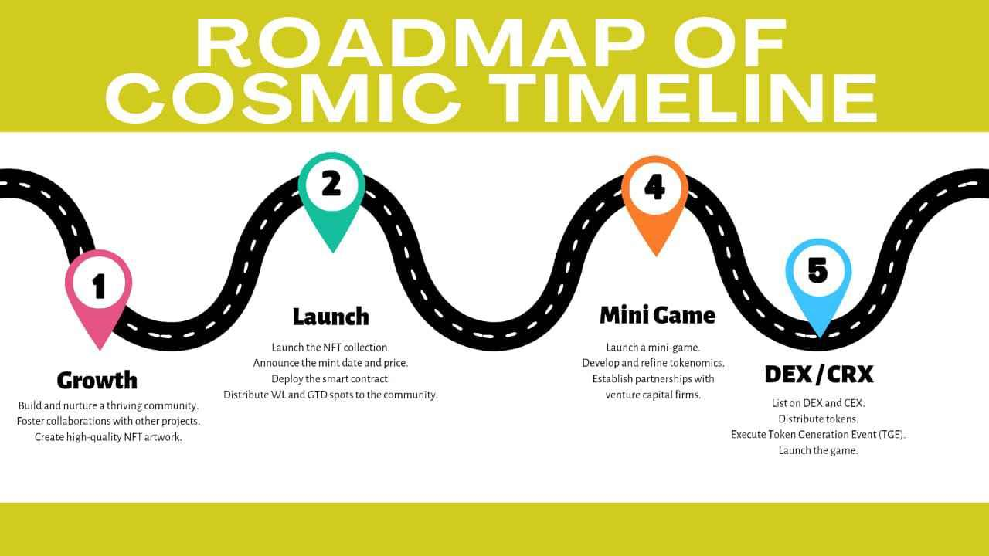

## **10. Conclusion**

Cosmic Timeline is **more than a project—it’s a movement**. By merging gaming, cryptocurrency, and decentralized governance, we are creating a **community-driven digital universe** where players have full control over their experience.

With **Cosmic Farmer, Cosmic Realm, Cosmo Kitty NFTs, and CosmoSprout Token**, we are setting the stage for a **sustainable, rewarding, and constantly evolving ecosystem**.

Join us as we **build the future of gaming and blockchain together**!

**Cosmic Timeline Team**

*Innovating the Future of Decentralized Gaming & Virtual Economies*